Chemical Health
Trend Corner:

Edible Marijuana

Easy to obtain edible Marijuana products like cookies, soda pops and baked goods are causing serious complications’ and death.
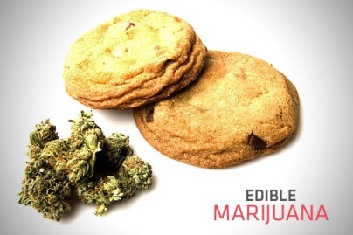
Part of the problem is that the effects of edible marijuana begin more slowly than smokeable pot, though they tend to last longer.

"One of the dangers that we've been seeing with adult recreational retail use is they'll take the recommended dose, wait, feel no effects and then continue to stack doses. Then before they know it they have a pretty large amount in their system and then they get potentially pretty severe effects," Dr. George Sam Wang said.

Investigators say that appears to be what happened to Levy Thamba, a college student from the Republic of Congo who had never tried marijuana before. Friends say he ate the recommended dose of one-sixth of a marijuana-infused cookie on March 11. When he felt no effects he ate the entire cookie: six times the recommended dose. He later became irrational and jumped off a hotel balcony to his death. Read Full Article:

Booze Brands in Pop Lyrics May Spur Teen Drinking

Adolescents hear 8 alcohol products mentioned a day on average, researchers report. Young people who listen to music that mentions specific alcohol brands are more likely to drink and abuse alcohol, a new study finds.

The average teen is exposed to about eight alcohol brand name mentions per day, said study corresponding author Brian Primack, an Associate Professor of Medicine and Pediatrics at the University of Pittsburgh.


Lisa Henriksen, Senior Research Scientist at the Stanford Prevention Research Center suggested that the inclusion of alcohol brands in music is a stealth marketing tactic used by the alcohol industry.

"It would be foolish to think that the alcohol industry is unaware of and uninvolved with alcohol-brand mentions in music," Henriksen said. "The strategy of associating products with hip culture and celebrities who are attractive to youth comes straight from a playbook written by the tobacco industry." Read Full Article:

Peer Influences: The Impact of Online and Offline Friendship Networks on Adolescent Smoking and Alcohol Use

Online social networking sites (SNSs) have become a popular mode of communication among adolescents. However, little is known about the effects of social online activity on health behaviors. The authors examined the use of SNSs among friends and the degree to which SNS activities relate to face-to-face peer influences and adolescent risk behaviors. Read Full Article:

Majority of High School Students Who Are Infrequent Marijuana Users Say They Would Not Use If Marijuana Were Legal

The majority of high school seniors who are infrequent users of marijuana report that they would not use the drug again if use were legalized, according to a recent analysis of combined data from the 2007 to 2011 national Monitoring the Future surveys. More than two-thirds (70%) of those who had only used marijuana one to five times in their lifetime said that they would not try the drug again if use were legalized. More frequent marijuana users, however, were more likely to report that they would use the drug as often or more often if use were legal. Read Full Article:

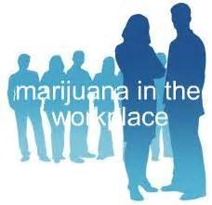
Legal Pot becomes Touchy Workplace Issue
Legalized marijuana in Colorado and Washington State is sparking new conflicts between employers trying to maintain drug-free workplaces and workers who say they're being punished for their off-duty indulgences.

Nearly half the states now legalize some sort of marijuana use, either for medical purposes or purely for fun. Twenty states now permit the use of marijuana for medical reasons, but employers in those states are under no legal obligation to allow any kind of pot use in the workplace. Colorado has a law that says workers cannot be fired for legal activities while off duty, but the state's courts also have said marijuana use isn't lawful because the federal government still considers it an illegal drug. Read Full Article:

As E-Cigarette Popularity Leaps, Worries of Illegal Drug Use Follow

E-cigarettes have fired up controversy in Minnesota this year as lawmakers wrestle with how to regulate the battery-powered devices that deliver nicotine without burning tobacco.

Nicotine, though, isn't the only addiction the products can deliver. E-cigarettes are also perfect for vaporizing illegal drugs and that has federal and state officials increasingly concerned. The U.S. Food and Drug Administration last week said it would seek new regulatory powers over the devices.

It's an issue that has the attention now of Minnesota law enforcement.

"Any type of water-soluble drugs -- and synthetic drugs would certainly fall into that category -- can be consumed through these e-cigarette devices that we're seeing more and more of," said Paul Wilson, a sergeant in the narcotics unit of the Rochester Police Department.
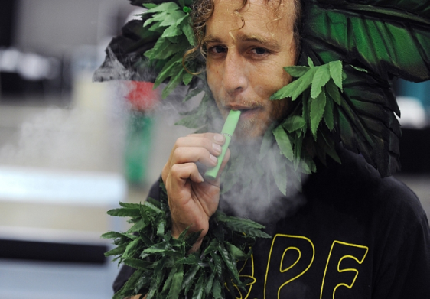
Read Full Article:


A man calling himself Henry Hemp inhales marijuana using a vaporizer pen at the HempCon medical marijuana show in May 2013 at the Los Angeles Convention Center.
Robyn Beck/AFP/Getty Images
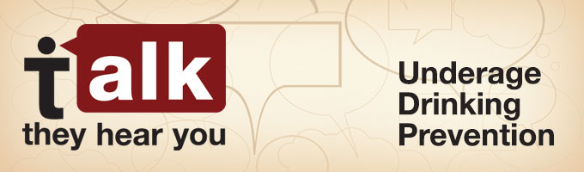
SAMHSA's underage drinking prevention campaign helps parents and caregivers start talking to their children early—as early as 9 years old—about the dangers of alcohol. Go To Website:

Will E-Cigarettes Cause More People to Smoke, or Fewer?

Will e-cigarettes eventually cause more people or fewer to smoke? Will the devices emerge as a healthier alternative that makes cigarettes obsolete, or will they act as a gateway to smoking and undermine a half-century of efforts to reduce tobacco-related deaths, which still kill an estimated 480,000 Americans annually? The Centers for Disease Control and Prevention reported this month that calls to poison centers involving e-cigarettes have surged in recent years as the products have gained in popularity, with most of the incidents involving children younger than 6 who have accidentally ingested the liquid nicotine. Dr. Oz Liquid Nicotine Video:

